God’s Plan for Me Lesson 4: Faith in Christ

The Bible clearly teaches that a person must have faith in God and Jesus Christ in order to be saved from sin. “And without faith it is impossible to please Him, for he who comes to God must believe that He is and that He is a rewarder of those who seek Him” (Hebrews 11:6). Jesus said: “Therefore I said to you that you will die in your sins; for unless you believe that I am He, you will die in your sins” (John 8:24). “For God so loved the world, that He gave His only begotten Son, that whoever believes in Him shall not perish, but have eternal life” (John 3:16). The apostle Paul said: “Therefore let it be known to you, brethren, that through Him forgiveness of sins is proclaimed to you, and through Him everyone who believes is freed from all things, from which you could not be freed through the Law of Moses” (Acts 13:38-39). Other scriptures teaching the necessity of faith include Mark 16:15-16, John 6:29, 11:25-27, 12:36, 20:31, Acts 10:43, 15:9, Romans 1:16, 3:25, and Ephesians 2:8.

Jesus Christ is God’s gift, which makes salvation possible, and this lesson will emphasize the importance of faith in Him. In order to obtain salvation, we must first learn what it really means to have faith in Christ.

1. We must accept the fact that Jesus is God’s Son and our Savior. We have not seen Jesus in person, but we believe that He really exists and that He walked on the earth in the First Century. We believe that He is God’s Son and our Savior. Why do we believe? Because of the testimony and evidence given in the Bible. Hebrews 11:1 defines faith as "a conviction of things not seen." We have never seen the famous people who lived and died many centuries ago, but we believe they lived because the evidence is so clear. In the same way, we have never seen Jesus in person, but we have the evidence concerning Him in the Bible (1 Corinthians 15:1-4). This evidence found in the Holy Scriptures produces our faith in Jesus. “So faith comes from hearing, and hearing by the word of Christ” (Romans 10:17).

Peter declared that those who believed in Christ did so because they had heard the gospel: “Brethren, you know that in the early days God made a choice among you, that by my mouth the Gentiles would hear the word of the gospel and believe” (Acts 15:7). Other scriptures producing belief in Jesus as our Savior include John 17:20, 20:31, and Acts 17:11-12.

2. We must do more than accept the fact that Jesus is God’s Son and our Savior. Believing that Jesus is the Son of God and the Savior of mankind is necessary, but it is not all that is required. John tells about some people who did believe but were not acceptable to God: “Nevertheless many even of the rulers believed in Him, but because of the Pharisees they were not confessing Him, for fear that they would be put out of the synagogue; for they loved the approval of men rather than the approval of God” (John 12:42-43). Jesus will not confess us before God unless we have enough faith to confess Him before others (Matthew 10:32-33).

James said, "The demons also believe and shudder" (James 2:19). We know that demons, though they believe, are disobedient and wicked and therefore are not saved.

While just believing is not enough, it is necessary for our salvation. No one would desire the salvation provided by Jesus until he was convinced of the gospel facts concerning Christ. When Hebrews 11:1 says that, "Faith is the assurance of things hoped for," it means that our hope is supported by faith. If people do not believe in Jesus Christ, then they have no reason to hope for salvation in Him. Believers have a reason for their hope, and they obtain the salvation hoped for when they do what God commands.
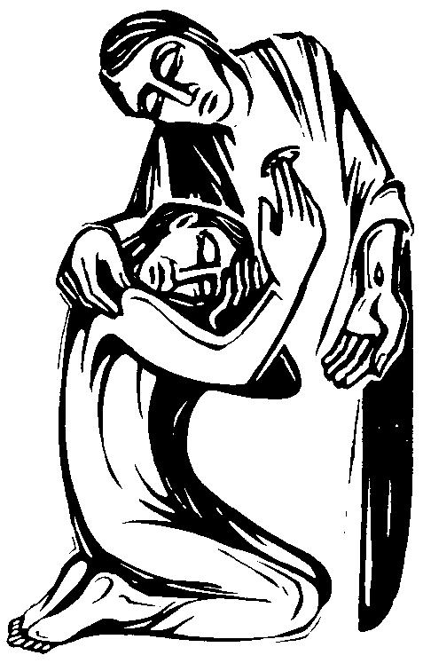
3. We must have trust in Christ. True believers accept the fact that Jesus is God’s Son and the Savior of mankind, and they then obey God’s commandments. They are able to do this because they learn to trust completely in Christ. People must learn to trust Christ for the salvation they cannot obtain from any other source.

We have not yet seen God. We have not yet seen the glory of Heaven. We do not know what it is like to die. Jesus has done all of these things, and we trust Him when He says, "I am the way, and the truth, and the life: no one comes to the Father, but by Me" (John 14:6).

4. We must obey the commands of the gospel. Obedience truly follows acceptance of Jesus as God’s Son and our Savior, and trusting Him for salvation. There is no real answer to the question of Jesus, "Why do you call Me, 'Lord, Lord,' and do not do what I say?" (Luke 6:46). One who will not obey Jesus has no reason to call Him “Lord.”

Near the end of the Sermon on the Mount, Jesus stressed the necessity of obeying the things commanded: “Not everyone who says to Me, ‘Lord, Lord,’ will enter the kingdom of heaven, but he who does the will of My Father who is in heaven will enter” (Matthew 7:21).

Peter and James also wrote about the importance of obedience: “Since you have in obedience to the truth purified your souls…” (1 Peter 1:22). “You see that faith was working with his works, and as a result of the works, faith was perfected” (James 2:22).

In Romans 6:17-18, Paul said that when the people in Rome "…became obedient from the heart [they were] made free from sin." Obedience is what changed them from servants of sin to servants of righteousness.

The Scriptures which teach that salvation is received by obedience do not conflict with those which teach that salvation is received by faith. Saving faith always produces obedience, because the faith which saves is the faith which obeys. In Hebrews 11:4-38 we have an impressive list of faithful people, and in each case they are described as doing something their faith led them to do.

In James 2, we see the importance of faith being expressed in obedience. After noting that the demons believe so strongly that they tremble in knowing their condition, James concluded: “Faith apart from works is dead” (James 2:26).

There is no conflict between James’ teaching of salvation by works and Paul’s teaching that salvation is by grace and faith. Paul taught: “For by grace you have been saved through faith; and that not of yourselves, it is the gift of God; not as a result of works, so that no one may boast” (Ephesians 2:8-9). He was simply saying that salvation is not earned or deserved. At the same time, however, he recognizes that saving faith calls for an obedient response. In his own life as a Christian, Paul’s most eloquent teaching was that the real person of faith is the one who obeys God. Those who have so little faith that they refuse to obey God are the ones who reject God’s saving grace.

Consider the link between belief, repentance, and baptism: “Peter said to them, ‘Repent, and each of you be baptized in the name of Jesus Christ for the forgiveness of your sins; and you will receive the gift of the Holy Spirit’" (Acts 2:38). “Of Him all the prophets bear witness that through His name everyone who believes in Him receives forgiveness of sins” (Acts 10:43). Clearly, the forgiveness of sins comes as the result of belief, repentance, and baptism.

It is easy to see that there is no conflict if one realizes that faith is a general term including everything involved in believing and obeying God. The people who heard Peter’s sermon and accepted it were baptized (immersed), according to Acts 2:41. Verse 44 describes the same people as those who believed. Obviously the word “believed” in verse 44 includes the act of baptism (mentioned in verse 41). In the same way, Crispus is described as one who believed (Acts 18:8) and one who was baptized (1 Corinthians 1:14).

In Acts 16:31 the jailer in Philippi was told: “Believe in the Lord Jesus, and you will be saved, you and your household.” By reading further, the text makes clear what the jailer understood belief to include. Verse 32 says that Paul and Silas preached the word of the Lord. Verse 33 says that the jailer and his household were baptized the same hour of the night. Unquestionably, they understood that the command to believe included baptism and other acts of obedience. In every other case of conversion described in the book of Acts, faith is always expressed in obedience to the Lord’s will. There is no exception.

We have learned in this lesson that faith in Christ is essential to salvation. The faith which saves is the faith of complete trust and the faith which causes us to obey every commandment given by God. May God bless you in believing, trusting, and obeying Him.

True or False (write T or F in the blank):

___ 1. As soon as one accepts the fact that Jesus is the Son of God, he is saved from his sins.
___ 2. To refuse to obey God is to reject God’s grace.
___ 3. Faith comes from hearing the gospel.
___ 4. The demons believe and tremble, yet are not saved.
___ 5. Without faith it is impossible to please God.

___ 6. The gospel explains what is necessary for salvation.
___ 7. Salvation is earned.
___ 8. To be saved, we must confess that Jesus is God’s Son.
___ 9. Everyone who says “Lord, Lord” will be saved.
___ 10. Those who believed the word in Acts 2 were baptized.

Multiple Choice (write the letter in the blank):

___ 11. “Faith without works is _____” (James 2:26).
a - complete b - dead c - perfect
___ 12. “_____ comes by hearing and hearing by the word of Christ” (Romans 10:17).
a - faith b - obedience c - judgment
___ 13. “And without _____ it is impossible to please Him” (Hebrews 11:6).
a - obedience b - love c - faith
___ 14. The Bereans examined the Scriptures daily _____ (Acts 17:11-12).
a - to show they were godly b - because they were bored c - to determine whether Paul was preaching the truth
___ 15. When someone obeys God from the heart, that person is _____ (Romans 6:17-18).
a - earning his salvation b - made free from sin c - a hypocrite
___ 16. Peter told the people in Acts 2:38 to “Repent and _____.”
a - pray b - ask the priest to pray c - be baptized
___ 17. After Paul and Silas taught the jailer he was _____ that same hour (Acts 16:33).
a - sick b - baptized c - hit by lightning
___ 18. Many of the Jewish leaders _____, but were afraid to confess Jesus (John 12:42-43).
a - believed b - lied c - laughed
___ 19. “No one comes to the Father, but _____” (John 14:6).
a - those who pray b - through me c - those who work hard
___ 20. James said that even the _____ believe and tremble (James 2:19).
a - murderers b - demons c - animals

Name: _______________________________ Address: ____________________________ City: _______________ State: ____ ZIP: ________

Four Lakes Church of Christ • 302 Acewood Boulevard • Madison, WI 53714-2511 • www.fourlakescoc.org • fourlakeschurch@gmail.com

